 | Tuesday, June 4th 8:30am – 5:00pm ET Meeting Room: TBD |  | (Level TBD)
 | 7:30 AM  8:30 AM  9:00 AM | Hosted Breakfast Room TBD  Welcome & Introductions  - Maurice Emsellem (CA), Chair of the NASWA EO Committee  - Liz Gagen (WY), Vice-Chair of the NASWA EO Committee  Vermont Office of Racial Equity Presentation  - Shalini Suryanarayana, Education & Outreach Lead
 | 10:30 AM | Break Room TBD
 | 11:00 AM  12:00 PM  1:30 PM  3:00 PM  3:30 PM  3:50 PM  5:00 PM  5:00-6:00 PM | 2024 William J. Harris Award Nomination Presentations  Maine: New Mainer Workforce Efforts  - Melissa Harvey  State: Nomination Topic  - Nominee  Hosted Lunch Room TBD  USDOL Civil Rights Center Update  - Naomi Barry-Perez (CRC)  - Miguel Escobar (CRC)  - Dong Hyuk Kim (CRC)  Break  NASWA Update  - Scott B. Sanders, President & CEO, NASWA  USDOL Employment & Training Administration Update  - Jim Garner (ETA)  - Michelle Beebe (ETA)  Adjourn  NASWA Reception Room TBD
Wednesday, June 5th 8:30am – 10:30am ET Meeting Room: TBD |  |  | (Level TBD)
 | 8:30 AM  10:30 AM | Breakfast – On Your Own  One-Stop AJC Visit (Optional)  Address: 63 Pearl St.  Burlington, VT 05401  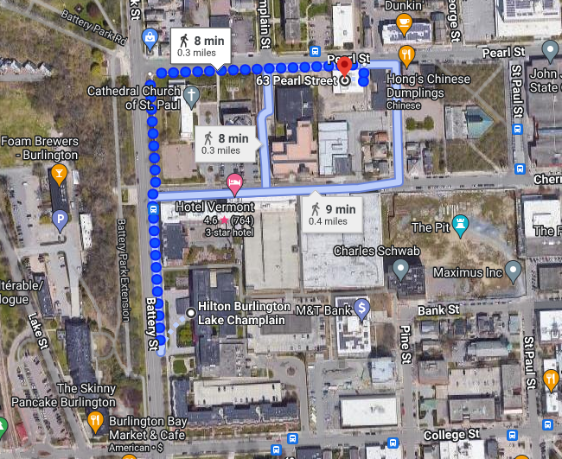  The tour is expected to last 45 minutes followed by meeting room availability to continue EO Committee discussions.  Adjourn
Save the Dates
Tuesday, September 24th | Equal Opportunity Committee Meeting | New Orleans, LA
Additional information can be found here and will be shared with committee members and contacts.
https://www.naswa.org/committees/equal-opportunity/equal-opportunity-committee-meeting-september-24-2024
Wednesday, September 25th – Thursday, September 26th | 2024 NASWA Workforce Summit | New Orleans, LA
Additional information can be found here and will be shared with committee members and contacts.
https://www.naswa.org/conferences/2024-naswa-summit

